Guided Capstone Project Report

Big Mountain resort in Montana is looking to see if a price increase in ticket prices was justified by longer ski runs and/or higher operating costs. A comparison of Big Mountain against data for other resorts in the US. 14% of the data was dropped for being incomplete. The weekday prices were also dropped due to a large number of them missing. The population data for the US was also downloaded and combined. A preliminary look at the data shows that Montana is the third largest in square miles as well as fourth largest in skiable area.

Night skiing and higher density seemed to have the most impact on price. One would think that having a higher amount of chairs would mean a higher price but this is not the case. On the contrary, more chairs probably means more people to make up the cost and lesser ticket prices. This must be kept in mind when thinking of the relationships certain elements might have on ticket price.

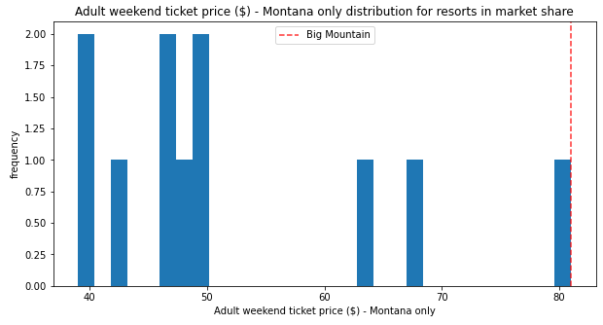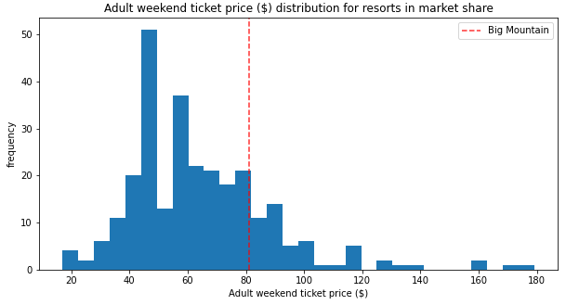Looking closer at how Big Mountain compares to other resorts in terms of ticket price currently, it is seen that nationally if falls close to the mean but on the higher end when compared to only Montana resorts.

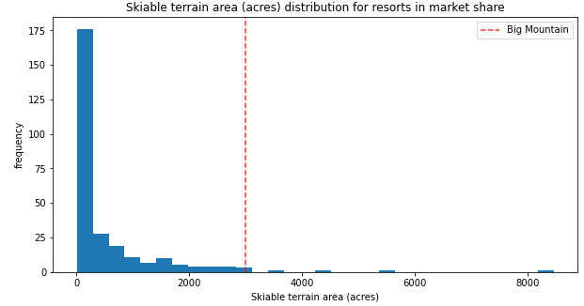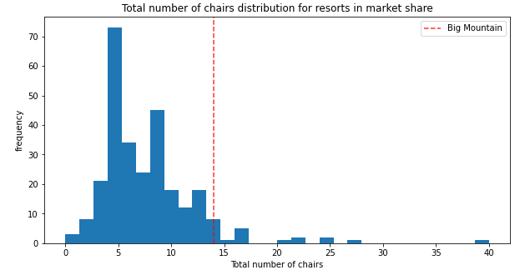However, when taking a look at skiable terrain and number of chairs, it is clear that Big Mountain is on the higher end.

A look was also taken into what removing a certain number of runs would do to ticket price and revenue.

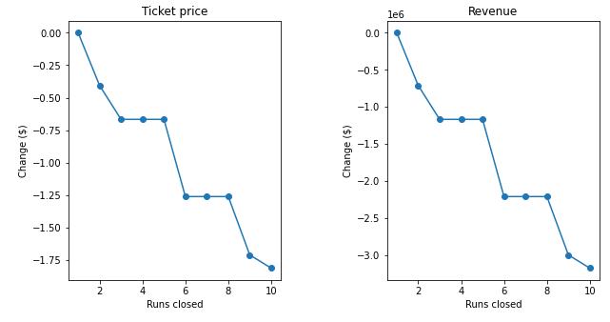

Initially when machine learning was used to model what the ticket price should be for “Big Mountain”, a price of $95.87 was spit out. Currently the price is set at $81 for the weekend. In our model there is an expected mean absolute error of $10.39 which means this price could potentially still be higher. Taking this all into consideration, a new chair lift would only cost $8.61 per ticket holder. To offset the costs a bit up to 5 runs could be closed with less than a $0.75 impact to the ticket price and only a little above 1% negative decline in revenue. Assuming the model was correct a price of $95.50 or higher would be more than sufficient to cover all of this and still leave “Big Mountain” as a desirable ski location.